# Change the permissions on a subfolder

Navigate to the site and library for which you want to create unique permissions on a subfolder.

If necessary, create the subfolder and add a few files.

On the subfolder name, do the following:

Next to the subfolder name, click the **Ellipsis…**

On the file popup window, click the **Ellipsis…,** and then click **Shared With**.

To view the folder’s Permissions page, click **Advanced**.

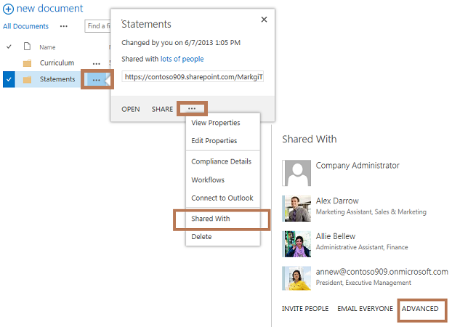

To remove permission inheritance for the folder, click **Stop Inheriting Permissions**.

For existing users, edit the permissions of those in the current list by selecting the check boxes and clicking either **Edit User Permissions** or **Remove User Permissions**.

For new users, click **Grant Permissions** and fill out the dialog box. Make sure you click **Show options** and select the appropriate permission level.